Benefits of Yoga
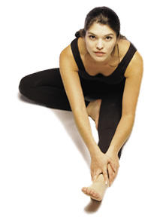
As we age, unless we develop a serious illness, we should be able to remain free of aches and pains and retain our ability to move about and be comfortable. Unfortunately, this is not the case for many. Some lifestyles cause muscles to be over-developed or under-developed. Some muscles are long and some are short and tight. Our joints may lose their range of motion causing basic movement to be difficult.
Many forms of movement in addition to yoga can be useful. Yoga, if practiced regularly, can help to balance our bodies and keep them in good working shape. Not only do we exercise all of our muscles and joints, we learn to breathe deeply and regularly. This increases oxygenation to tissues.
A recent study conducted on women in nursing homes indicated that elderly women who regularly participate in yoga classes have fewer complaints of aches and pains than women who are sedentary. Yoga can reduce the medication requirements of patients with asthma. It has been shown to be more effective than splinting in patients with carpal tunnel syndrome. Patients with arthritis of the hands who used yoga, improved significantly more than the control group in their experience of pain, activity, tenderness, and finger range of motion. In some patients, yoga is more effective than medication in reducing anxiety. Because yoga practice includes breathing exercises and meditation, yoga practitioners tend to be calmer and less reactive to outside circumstances.

